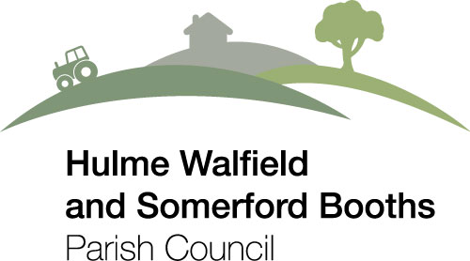

You are hereby summoned to attend the Parish Council Meeting to be held at 7.30pm on Thursday 21st April 2022 at Westlow Mere Fisheries.

Members: Cllr. V Brown (Chairman), Cllr. J Spence, Cllr. M Hill (Vice Chairman), Cllr. A Scott, Cllr. M Wakerly

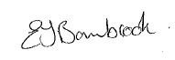

Clerk of the Council: Emma Bambrook
Dated: 8th April 2022
28 Leat Place, Bollington, Macclesfield, Cheshire, SK10 5DF
Email: clerk@hwsbparishcouncil.co.uk
Tel: 07967 302707

AGENDA

PART 1 - PUBLIC AND PRESS
There will be an opportunity for public participation at the start of the meeting at the discretion of the Chairman. This period will last for no longer than 10 minutes.

- To receive and approve apologies for absence.

- To receive any declarations of interest

- To receive and resolve to approve the minutes of the Parish Council meeting held on 17th March 2022

- To consider the following planning applications and any others since the publication of the agenda:

- To ratify the comments submitted for the following planning applications which required comments before this meeting:

22/0670C Land East of VIKING WAY, CONGLETON, CW12 1TT RESERVED MATTERS FOLLOWING OUTLINE APPROVAL. Reserved matters application proposing details for the appearance, scale, layout and landscaping for a residential development at Viking Way, Congleton. An Environmental Impact Assessment was submitted to the Local Planning Authority as part of the outline.

View Comments Submitted

- To receive and resolve to approve the accounts for payment:

BALANCE OF ACCOUNT = £28834.99

PAYMENTS

£150.00 Parish Magazine Contribution
£111.80 HMRC Income Tax
£176.40 ChALC Affiliation Fee
£ 40.00 Clerk’s Expenses (Reimbursement for payment of ICO registration fee)
£750.00 Donation to The Disasters Emergency Committee Ukraine Appeal
£750.00 Donation to International Aid Trust Ukraine Appeal
£500.00 Siddington PCC CAF Benefice Ukraine Appeal
£2500.00 Grant to Alderley Gate Resident’s Group
£ 8.00 HSBC Bank Charge

RECEIPTS

£5750.00 Cheshire East Council Precept Payment 1st Instalment

Bank reconciliation to be signed by a councillor.

- To consider continuing the Emergency Scheme of Delegation to the Clerk which will operate between Parish Council Meetings. This scheme of delegation was put in place in anticipation of the tightening of Government Restrictions in relation to COVID-19 (or other emergency situation) which may stop Parish Councils Meeting face to face. For reasons of health and safety of Councillors, employees, and the public the adopted the scheme to operate between meetings and to allow meetings to take place if it is safe to do so. This means that a standing item will be added to each Parish Council Meeting Agenda, to continue the scheme of delegation to the Clerk until the next meeting.

- To note the date of the next parish council meeting to be held on 5th May 2022

